**English Template Manuscript**

|  |  |  |
| --- | --- | --- |
| **Received:** xxxxxxxxxxx | **Revised:** xxxxxxxxxxx | **Accepted:** xxxxxxxxxxx |

**English Title**

(TH Sarabun PSK, 20 pt., Bold)

**1 Enter 16 pt.**

**Name/Lastname1*//Name/Lastname2//and//Name/Lastname2**

(TH Sarabun PSK, 16 pt., Bold)

(In case there is more than one researcher, list the principal investigator's name first. If any co-researchers are affiliated with a different institution than the principal investigator, indicate their affiliation with a corresponding number)

**1 Enter 16 pt.**

**Department, Faculty, University, Province, Country Postal code**

(TH Sarabun PSK, 12 pt., Bold)

**1 Enter 16 pt.**

**Abstract** (TH Sarabun PSK, 16 pt., Bold)

**1 Enter 16 pt.**

**(1 Tab)** (TH Sarabun PSK, 16 pt.)

…………………………………………………………………………………………………………………..............................................................…

…………………………………………………………………………………………………………………………………………………………………………………………………………………………………………………………………………………………………………………………………………………………

**1 Enter 8 / 10 pt.**

**Keywords:///**……...,/……...,/……...,/……...,/……... (TH Sarabun PSK, 16 pt.,) 3-5 words

*Corresponding author: ……………@...........

**Introduction** (TH Sarabun PSK, 14 pt., Bold)

**1 Enter 14 pt.**

**(1 Tab)** (TH Sarabun PSK, 14 pt., Regular) .......................................................................................................................................

………………………………………………………………………………………………………………………………………………………………………………………………………………………………………………………………………………………………………………………………………………………………………………………………………………………………………………………………………………………………………………………………………

**1 Enter 14 pt.**

**Materials and Methods/ Research Methodology** (TH Sarabun PSK, 14 pt., Bold)

(If the work falls under the science category, use 'Materials and Methods.' If it falls under the category of social sciences, use 'Research Methodology.')

**1 Enter 14 pt.**

**(1 Tab)** (TH Sarabun PSK, 14 pt., Regular) ……………………………………………………………………………………………………….……………….

………………………………………………………………………………………………………………………..……………………………………….……………………………………………………………………………………………………………………………………………………………..…………….………………………………………………………………………………………………………………………………………………………………………………………

**1 Enter 14 pt.**

**Results and Discussion** (TH Sarabun PSK, 14 pt., Bold)

**1 Enter 14 pt.**

**(1 Tab)** (TH Sarabun PSK, 14 pt., Regular) ……...................................................................................................................................

………………………………………………………………………………………………………………………………………………………………..…………………………………………………………………………………………………………………………………………………………………………..………………………………………………………………………………………………………………………………………………………………………………………

**1 Enter 14 pt.**

**Conclusion** (TH Sarabun PSK, 16 pt., Bold)

**1 Enter 14 pt.**

**(1 Tab)** (TH Sarabun PSK, 14 pt., Regular)……….....................................................………………………………….……….……………..………

…………………………………………………………………………………………………………………………………………………..…………………………………………………………………………………………………………………………………………………………………………..……………………………………………………………………………………………………………………………………………………………………….………………………….. **1 Enter 14 pt.**

**Recommendations** (TH Sarabun PSK, 14 pt., Bold)

**1 Enter 14 pt.**

**(1 Tab)** (TH Sarabun PSK, 14 pt.)………………….............................................…….……………………………………..…

……………………………………………………………………………………………………………………………………………………………...……………………………………………………………………………………………………………………………………………………………………..………………………………………………………………………………………………………………………………………………………

**1 Enter 14 pt.**

**Acknowledgment** (TH Sarabun PSK, 14 pt., Bold)

**1 Enter 14 pt.**

**(1 Tab)** (TH Sarabun PSK, 14 pt.)……………………………………………………………………………..........…………..….……

………………………………………………………………………………………………………………………………………………………………………………………………………………………………………………………………………………………………………………………………………………………………………………………………………………………………………………………………………………………………

**1 Enter 14 pt.**

**References** (TH Sarabun PSK, 14 pt., Bold)

**1 Enter 14 pt.**

(TH Sarabun PSK, 14 pt., Regular) ……………………………………………………………………………………

**(1Tab)**……………………………………………………………………………………………………

(TH Sarabun PSK, 14 pt.) ……………………………………………………………………………………

**(1Tab)**……………………………………………………………………………………………………

(TH Sarabun PSK, 14 pt.) ……………………………………………………………………………………

**(1Tab)**……………………………………………………………………………………………………

(TH Sarabun PSK, 14 pt.) ……………………………………………………………………………………

**(1Tab)**……………………………………………………………………………………………………

**(APA 7th edition or American Psychological Association style)**

*The maximum of the article is 8 - 15 pages

**Authors must integrate tables, figures, and images within the main text. Formatting should adhere to the prescribed journal guidelines as specified below**

**Table/1**(TH Sarabun PSK, 14 pt., Bold)**//**Description (TH Sarabun PSK, 14 pt., Regular)

**1 Enter 8 pt.**

|  |  |  |  |  |
| --- | --- | --- | --- | --- |
| **No.** | **Place** | **Sample** | **Positive** | **% Positive** |
| 1 | Sriracha | 20 | 0 | 0 |
| 2 | Muang Chonburi | 25 | 8 | 32.00 |
| 3 | Phanat Nikhom | 41 | 9 | 21.95 |
| 4 | Koh Sri-chang | 33 | 6 | 18.18 |
| **Total** | | 119 | 23 | 19.33 |

**1 Enter 5 pt.**

**Note:** Description (TH Sarabun PSK, 12 pt., Regular)…………………………………………………………………………

**1 Enter 14 pt.**

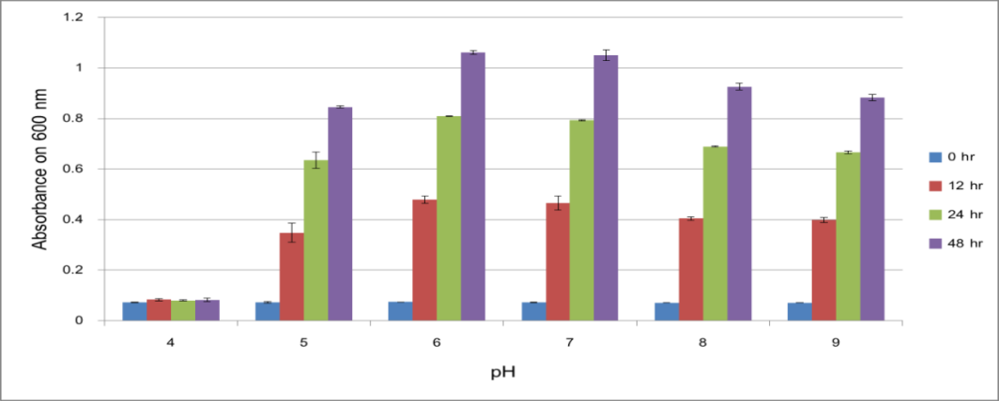

**1 Enter 14 pt.**

**Figure/1** (TH Sarabun PSK, 14 pt., Bold)**//** Description(TH Sarabun PSK, 14 pt., Regular)……………………..

**1 Enter 14 pt.**

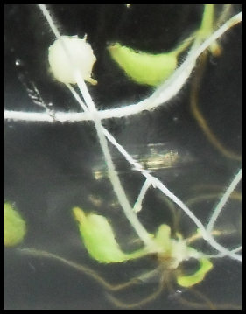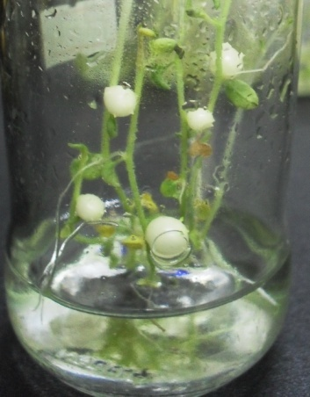

**A**

**B**

**1 Enter 14 pt.**

**Figure/1** (TH Sarabun PSK, 14 pt., Bold)**//** Description (TH Sarabun PSK, 14 pt., Regular)…………………

*Resolution of pictures no less than 300 DPI